**Chapter 1**

# 1.INTRODUCTION

The technology aims in imparting a tremendous knowledge oriented technical innovation these days. Generally, in the classroom the attendance was taken by the teachers manually at the beginning and ending of the class. The problem with this approach is that it requires some time to take attendance and the manual process will have chances to make mistakes in most of the cases. To overcome that problem, RFID (Radio Frequency Identification) was introduced in the past years. But those are also having the fail proof of attendance system. So, we are introducing the concept of Face Recognition Based Student Attendance System. The main objective of proposed system is to allot attendance to the students using face recognition-based algorithms to achieve fail proof attendance system.

Face detection is used for many applications for the identification of human faces in digital images or video. It is defined as specific case of object-class detection; where it is used to find the locations and sizes of all objects in an image that belong to a given class. The technology is can be able to predict fontal or near-frontal faces in a photo, regardless of orientation, lighting conditions or skin color.

Face Recognition is a form of biometric software that maps an individual’s facial features mathematically and stores the data as a face print. The software consists of Deep Learning algorithms to compare a live capture or digital image to the stored face print in order to verify an individual’s identity.

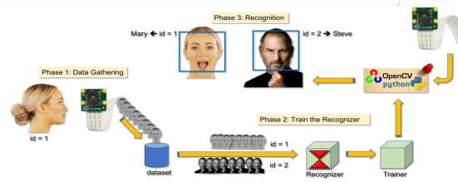

Figure 1.1: Real time face Recognition

Computer Vision is one of the most fascinating and challenging tasks in the field of Artificial Intelligence. Computer Vision serves as a link between computer software and the visuals we see around us. It enables computer software to comprehend and learn about the visuals in its environment. As an example: The fruit is determined by its color, shape, and size. This job may seem simple for the human brain, but in the Computer Vision pipeline, we first collect data, then conduct data processing operations, and then train and educate the model to learn how to differentiate between fruits based on size, shape, and color. The main goal is to identify and comprehend the images and offer new images that are more useful for us in different life fields.

The term "OpenCV" is an abbreviation for "open source computer vision." The architecture is made up of software, databases, and plugins that are pre-programmed with support for integrating computer vision applications . It is one of the most used toolkits with a large developer group. It is well-known for the size at which it builds real-world usage cases for industrial use. OpenCV follows C/C++, Python, Java programming languages and can be used to build computer vision software for desktop and smartphone platforms such as Windows, Linux, macOS, Android, and iOS. The most recent releases are OpenCV-4.5.2 and OpenCV-3.4.14. It is free and open-source, as well as simple to use and install. It is intended for numerical productivity with a heavy emphasis on real-time applications. The first version was in the C programming language; however, its success increased with the release of Version 2.0, which had a C++ implementation.

C++ is used to create new features. OpenCV can be downloaded for free from http://opencv.org. This platform includes the most recent distribution update as well as older iterations. Photos must be in BGR or Grayscale format in order to be displayed or saved via OpenCV. Otherwise, unfavorable outcomes could occur.

Face detection is a form of computer vision that aids in detecting and visualizing facial features in captured pictures or real-time videos. This type of object detection technique detects instances of semantic artifacts of a given class (such as people, cars, and houses) in digital pictures and videos. Face recognition has become increasingly important as technology has advanced, especially in fields such as photography, defense, and marketing.

The emphasize the important role of OpenCV in face detection and face recognition, what algorithm can be used in OpenCV for face detection and face recognition, then state the OpenCV modules and explain OpenCV based on Python and mention the applications for OpenCV are. Finally, we assessment and compared recent literature reviews that use OpenCV to detect and recognize the human face in a variety of fields in order to improve human life.

The rest of this paper is organized as follows: Face detection is described. In section 3, face recognition is explained.OpenCV library and OpenCV algorithm is explained. Modules of OpenCV are explained.OpenCV based on Python is described. The assessment of literature reviews and comparison table are discussed. Section 8 concludes this paper.

Recognition is a modern field of study that has piqued the interest of researchers since it becomes simple to use by using OpenCV-based Python. Face recognition technologies have a variety of applications in public protection, entertainment, man-machine contact, and social networking, such as Facebook's automated tag recommendation on images. It's also been seen in educational and non-educational institutes' attendance control, financial offices, voter registration, and other areas.

* **Face Detection:**

Face detection has received much attention in recent years because of its applications in computer and human interaction. Face detection is a subset of image processing. Image processing is primarily a technique for compressing, improving, or extracting valuable information from images. Facial recognition technology can identify single or many faces in a picture, removing unwanted background noise. A face identification algorithm must basically categorize pictures into two groups based on whether or not they include a face. The face detection algorithm's goal is to thoroughly examine the picture, identify the existence of faces in the image, and remove the background from the image. Face detection mistakes are classified into two types: false negative and false positive. A false positive occurs when a face is identified in a picture that does not include any faces. A false negative occurs when the algorithm rejects the existence of anything in the picture. The detection rate is the ratio of the number of faces identified by humans to the number of faces detected properly by the system. The detection rate of the face detection algorithm should be as high as possible.

**Face Recognition:**

Facial recognition is the world's most advanced and quick biometric technology. It takes advantage of the most visible human body component, the face, in a non-intrusive way. According to worldwide data, most individuals are unaware of the face recognition process that is taking place on them, making it one of the least invasive procedures with the least amount of delay. The facial recognition algorithm examines the many features of a face in the input picture. This biometric has been extensively, and maybe exaggeratedly, lauded as a great method for identifying possible dangers such as terrorists, scam artists, and so on, but it has yet to gain widespread acceptance in high-level use. Biometric face recognition technology is expected to surpass fingerprint biometrics as the most common method of user identification and authentication in the near future.

* **OpenCV Library:**

It is a massive open-source image processing, machine learning, and computer vision library. OpenCV is compatible with a broad range of programming languages, including Python, C++, and Java. It will analyze photographs and videos to recognize artifacts, faces, and even human handwriting. When paired with many other libraries, like Numpy, a high-performance library for turning machines, achieve a good performance; that is, all services that can be performed in Numpy can also be integrated with OpenCV.

It is written based on C++ and has a C++ interface as its main interface, but it also has a less robust but still detailed older Language training. Both the latest technologies and algorithms are visible in the C++ GUI. Python, Java, and MATLAB/OCTAVE bindings are available. Wrappers in a variety of programming languages have been created to promote broader acceptance. JavaScript plugins for a variant of OpenCV functions are published as OpenCV.js in version 3.4, which can be used on web platforms. The OpenCV project, which was officially unveiled in 1999, was originally Intel's research program to support CPU-intensive applications .OpenCV is a popular platform for implementing face detection and recognition algorithms. The following are some often used OpenCV algorithms.

**Haar Cascade:**

Haar Cascade is an effective method for detecting objects. It's a machine-learning-based method in which a cascade of actions is learned from a large number of positive and negative images. It becomes used to seeing things in different frames. Fig. 1.2 shows the view of the Haar cascade classifier. Fig. 1.3 shows the Haar cascade flowchart.

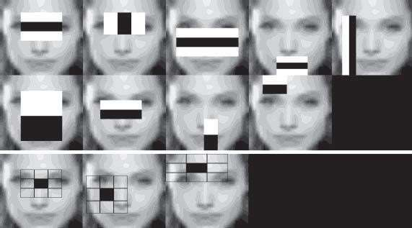

Figure 1.2: View of Haar cascade classifier

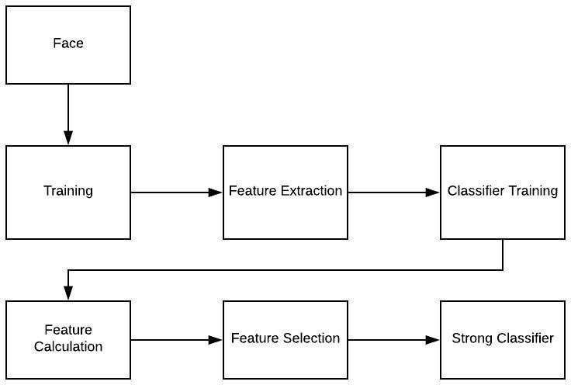

Figure 1.3: Haar Cascade flowchart

**LBP (Local Binary Pattern):**

It is a simple but effective texture operator that labels pixels in an image by thresholding the pixels neighborhood and treating the result as a binary number. The LBP texture operator has become a common approach in a variety of applications due to its discriminative power and computational simplicity. It can be viewed as a unifying solution to texture analysis's historically divergent statistical and structural models. The LBP operator's robustness to monotonic grayscale changes induced, for example, by illumination variations is perhaps its most significant property in real-world applications. Another key feature is its computational simplicity, which allows it to analyze images in difficult real- time scenarios. Fig. 1.4 shows the description of facial expressions with local binary patterns.

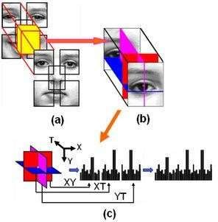

Figure 1.4: Description of facial expressions with local binary patterns

**Eigen Faces:**

It is a method that employs PCA (Principal Component Analysis) to minimize dimensionality and find the strongest vectors for distributing facial images onto existing facial spaces. The primary goal of PCA is to identify the best vectors to explain the distribution of facial images in picture space into face space. According to the eigenvalue distribution, m eigenvector is used to construct the principal component amount. Eigenvector and eigenvalue are calculated from the qualified facial image's covariance matrix. The eigenvector is sorted by eigenvalue (high to low) and M first eigenvectors are chosen to form the principal variable.

* **Fisher Faces:**

It is a face recognition system that several researchers have demonstrated to identify faces accurately. Fisher Face is a calculation model that combines the PCA (Principal Component Analysis) calculation model with Fisher's Linear Discriminant (FLD). PCA is used to minimize input data in order to simplify and accelerate the FLD operation. On the other hand, FLD is used to generate a distribution matrix to aid in classification and identification. A series of Fisher Faces is generated using the PCA and FLD calculation models. This facial recognition process consists of four major steps: face identification, PCA estimation, calculation, and classification.

* **LBPH (Local Binary Pattern Histogram):**

LBP is a highly effective texture operator. That compares each neighboring pixel's threshold value to the value of the center pixel. It takes into account outcomes in the context of binary numbers. LBP is a common technique in a variety of applications due to its discriminative strength and simplicity. LBP was identified for the first time in 1994. Since then, it seems to have evolved into a more efficient texture classification algorithm. It was later discovered that combining LBP with histograms of directed gradient descriptors increases its accuracy on the same dataset. LBP has additional capabilities such as monotonic grey-scale improvements and statistical simplicity, allowing it to interpret images in real-time applications. Fig. 1.5 shows the LBPH algorithm for face recognition.

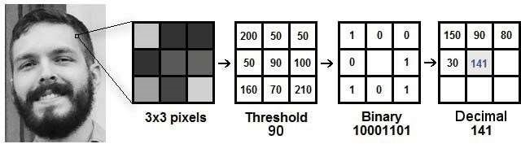

Figure 1.5: LBPH Algorithm for Face Recognition

* **YOLO:**

Yolo is an abbreviation for (you only look once). It is the most recent real-time object detection system that uses a single neural network to process the entire image. This network splits the picture into sections and estimates the bounding boxes and probabilities for each the estimated probabilities are used to weigh these bounding boxes. The testing phase examines the whole picture, so the image's global meaning guides its predictions.

Can detect objects form videos or image. Fig. 1.6 shows the Yolo process.

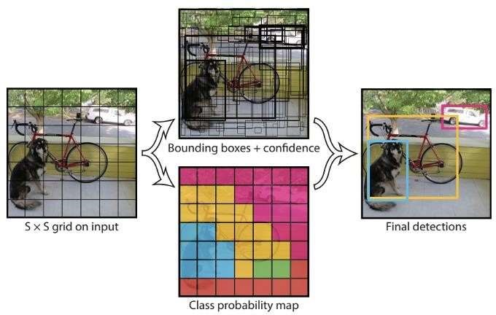

Figure 1.6: The Yolo process

* **Faster R-CNN:**

It is a popular object detection architecture proposed in 2015 by Ross_Girshick and is one of the most well-known object detection architectures that employ convolution neural networks. The implementation of the Region Proposal Network enables (Faster R-CNN) easier and quicker (RPN). RPN is a completely convolutional network that has been trained side-to-side, and forecasts object boundaries and object ratings at each detection. Since RPN is so critical to (Faster-R-CNN), and remains one of the strongest entity detection frameworks open to researchers, most of this piece would concentrate on RPN architecture and the notions of anchor boxes and suppression non-maximum. Fig. 1.7 shows the Faster_ R-CNN step.

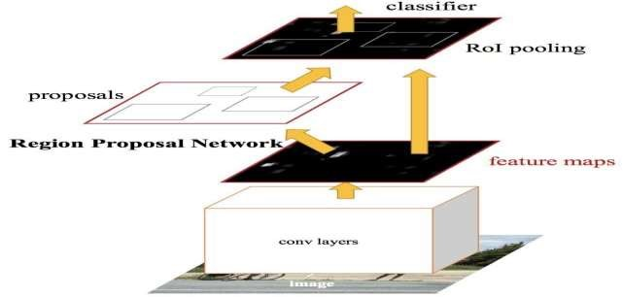

Figure 1.7: Faster_R-CNN step

* **Single Shot Detectors (SSDs):**

The SSD method is focused on the feed-forward convolutional network that generates a permanent border-box array and results in the existence of class-based entity instances in these boxes and a non-maximum deletion stage to generate final detection. The early network layers are built on a common image classification design. Fig. 1.8 shows the SSD.

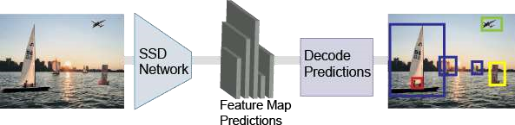

Figure 1.8: SSD

## 1.1Background

Maintaining the attendance is very essential in all the educational institutions for checking the performance of students. Many biometric systems are available in the market but the key authentications are same in all of the techniques. Every biometric system consists of enrollment process in which the unique features of a person is stored in the database and after that, there are some processes of identification and verification of the person. These two processes compare the biometric feature of a person with previously stored template captured at the time of enrollment of a student.

## 1.2Problem Statement

According to the previous attendance management system, the accuracy of the data collected is the biggest issue. This is because the attendance might not be recorded personally by the original person, in another word, the attendance of a particular person can be taken by a third party without the realization of the institution which violates the accuracy of the data. For example, student A is lazy to attend a particular class, so student B helped him/her to sign for the attendance which in fact student A didn't attend the class, but the system overlooked this matter due to no enforcement practiced. Supposing the institution establish enforcement, it might need to waste a lot of human resource and time which in turn will not be practical at all. Thus, all the recorded attendance in the previous system is not reliable for analysis usage. The second problem of the previous system is where it is too time consuming.

Assuming the time taken for a student to sign his/her attendance on a 3-4 paged name list is approximately 1 minute. In 1 hour, only approximately 60 students can sign their attendance which is obviously inefficient and time consuming. The third issue is with the accessibility of those information by the legitimate concerned party. For an example, most of the parents are very concerned to track their child’s actual where about to ensure their kid really attend the classes in college/school. However, in the previous system, there are no ways for the parents to access such information.

Therefore, evolution is needed to be done to the previous system to improve efficiency, data accuracy and provides accessibility to the information for those legitimate parties.

## 1.3 Objectives

The proposed system will reduce the paperwork where attendance will no longer involve any manual recording. The new system will also reduce the total time needed to do attendance recording. The new system will acquire individual attendance by means of facial recognition to secure data accuracy of the attendance.

The following are objectives of the project:

* To develop a portable Smart Attendance System which is handy and self-powered?
* To detect unique faces with the help of computer’s camera
* Able to recognize the face of an individual accurately based on the face database.
* Allow parents to track their child’s attendance.
* Develop a database for the attendance management system.
* Allow new students or to store their faces in the database by using a GUI

## 1.4 Project Features

1. Long term storage of records
2. High accuracy in calculation
3. Time saving
4. Optimize the resources
5. Efficiency in modification, sorting and retrieval of data
6. Inexpensive updating in facilities and terms of organizations.

## 1.5Scope and Limitations

As with any technology, there are potential drawbacks to using facial recognition, such as threats to privacy, violations of rights and personal freedoms, potential data theft and other crimes. There’s also the risk of errors due to flaws in the technology. Though there are some weaknesses of this system, there is a tremendous scope in present world. Here we discuss about scope and limitations of our project.

**1.5.1Scope of project**

1. The main intention of this project is to solve the issues encountered in the old attendance system while reproducing a brand new innovative smart system that can provide convenience to the institution.
2. Provides facility for the automated attendance of students.
3. An excel sheet is created which contains the student attendance and is mailed to the respected faculty.

**1.5.2 Limitation of project**

1. The main problem of face recognition is large variability of recorded image due to pose, illumination condition, facial expression, different hairstyles, presence of glasses, beard.
2. Difficulties in code writing.
3. Difficulty to overcome ambiguity.

**Chapter 2**

# LITERATURE REVIEW

## 2.1 INTRODUCTION

The literature review deals with the topics and the researches that would help to understand Face Recognition Based Student Attendance System from the existing systems that are similar to Face Recognition Based Student Attendance system. The objective of this literature review is to analyze the related work to this project and mechanisms used in previous studies.

## 2.2 Signature Based Attendance System

According to our first research, we have “Smart Attendance Management and Analysis with Signature Verification.” This project is the Smart Attendance Management and Analysis System where after getting individual's signature of the student, the signature is scanned and converted into an image file. After segmentation, features are extracted from the signature. Verification of signature is made with the Database of student’s Signature and Excel sheet of absence and presence of student's attendance is generated. Signature is one of the most popular and legally accepted biometrics used in one’s person identification. A handwritten signature is one of the ways to verify person’s identity in legal, financial and administrative areas.

## 2.3Fingerprint Based Attendance System Using Microcontroller and LabVIEW

According our next research journal “Fingerprint Based Attendance System Using Microcontroller and LabVIEW” proposed a solution of using fingerprint to mark the attendance. This system is using 2 microcontrollers to deal with the fingerprint recognition process. Firstly, the fingerprint pattern will be obtained through a fingerprint sensor, then the information will be transmitted to microcontroller 1.

Next microcontroller 1 will pass the information to microcontroller 2 to do the checking with the database that resides in it. After finding a student’s match, the details are sent to the PC through serial communication to be displayed. This design is good as it accelerates development while maintaining design flexibility and simplifies testing. But again, this system is attached to a PC which makes it not portable. Other than that, the database information cannot be accessible easily.

## 2.4 RFID Based Student Attendance System

RFID – Radio Frequency Identification is one method for attendance making. In this technology an individual has to carry his own RFID card. Therefore, this system is cost effective and can also give rise to fraud as any unauthorized person can use the card for fake attendance.

## 2.5 Face Recognition Attendance System

This is one of the most efficient systems of all existing ones for identification of people. It can be used in school, colleges, or any organization. To avoid the difficulty of taking attendance of enormous number, there is a need of automated attendance system that is fast and reduces the chance of fake attendance. In this technology system is developed for deploying an easy and secure way of taking down attendance.

This attendance is recorded, by continuously detecting faces of employees or students via camera as they enter the classroom. The software first detects the faces and simultaneously compares them with the predefined database.

**2.5.1 Comparison Of Classifiers:**

|  |  |  |  |  |  |  |  |  |  |  |
| --- | --- | --- | --- | --- | --- | --- | --- | --- | --- | --- |
| **Ref.** | | **Aim** | | **Classifier** | | **accuracy** | | **Result/purpose** | | |
| 2018 | | SVM | | OpenCV more accurate than Dlib | | 83% head  detect | | The OpenCV library is more productive, has improved facial recognition and detection accuracy | | |
| 2018 | | Head Detection and Tracking | | Haar-like  CMT  Cascade | | 68% tracking | | The proposed system successfully detected the head of human using OpenCV libraries, specifically using Haar-like attribute detection. | | |
| 2018 | | comparative of classifying the face using different classifiers | | MLP  Extra Tree  (Random  Forest)  KNN  RadialSVM  GaussianNB  LinearSVM  (Logistic  Regression) | | 99.1% 86.4% 95.9%  99.3% 98.4% 98.8% 99.2%  99.4% | | The results show that Logistic Regression outperforms the other algorithms for face classification in terms of speed and accuracy. | | |
| 2018 | | real-time recognition Facial emotion | | Haar  SVM | | 93.7% | | The findings suggest that with today's computing power, user-independent, completely automated real-time coding of facial expressions in a continuous video stream is a goal that can be achieved. | | |
| 2018 | | Face Detection under Different  Lighting | | Haar | | 80% | | The experiment demonstrated that the picture processing system has facial recognition in various lighting conditions. | | |
| 2019 | | Designing of  Face  Recognition  System | | Haar-like  LBPH | | 80% | | The system is tested by more than 150 people and has a reliability of approximately 80%. It is measured with multiple cameras in various settings, and lighting conditions, and the findings are about the same. A Logitech C90 USB webcam is used here. | | |
| 2019 | | Student  Monitoring  System for  School Bus | | Haar-  Cascades  LBPH  Eigenfaces | | 85% | | The system watches the bus and detects the students and their movements, acknowledges the faces of the students, and their count is also tracked and alerts the audience if necessary. | | |
| 2019 | | Face  Recognition in  Parallel  Computer | | Keras VGG- Face | | module  performance depends on the number  of processors | | The results collected were rather similar to what was predicted. The efficiency gained by simply running the program on a machine with more computing capacity and cores than a simple laptop was important. | | |
| 2019 | | Recognition of the gender, age, and face of the person | | cascade  LBP  LBPH | | successfully  work but affected by mobile type, face coverage, expressions of face, | | Gender, face, and age achieved | recognition was | |
| 2019 | | criminal identification by face recognition automated | | Haar-like | | 80% | | Since the computation period is very short, the proposed  successfully identify more than one face, which is helpful for rapidly looking for suspects. | method will | |
| 2020 | | Automated  Attendance  System | | KNN  HaarCascade  LBPH | | 97% | | Prevent students from marking fake attendance for other students. It would  also save faculty  universities by eliminating the need for them to take attendance of students who | resources in | |
|  | |  | |  | |  | | are present in class, and it will be able to send monthly attendance reports to students' parents by email. | | |
| 2020 | | Attendance System in realtime | | HaarCascade Paul – Viola. | | 95% | | The results explicitly demonstrate that as the facial angle increases, face identification and recognition rate decreases. | | |
| 2020 | | real-time system of electronic voting authorized by face recognition | | Haar-cascade  Camshaft | | 90% | | The primary goal of this project is to completely concentrate on the electronic voting mechanism and the protection of every organization. | | |

2020 Face Mask Cascade between Since wearing a mask which becomes Detection to CNN 95.77%, mandatory before the Covid-19 crisis is protect from 94.58% resolved, the implemented model can

Covid-19 make a significant contribution to the

public health care system.

|  |  |  |  |  |  |
| --- | --- | --- | --- | --- | --- |
| 2020 | Autonomous  Face Detection  System from  Real-time  Video  Streaming | | Haar Cascade | 83% | Recognize human faces with some kind of camera and issue an alarm with a buzzer and an automatic-on light bulb that makes it noticeable from a long distance. |
| 2020 | Counting students in classroom allocation | | Cascade | 90 to 100%. | By installing cameras in the hallway, the model may be used to detect students who are skipping classes. |
| 2019 | A Face Recognition and Static Hand Gesture System for the Blind | | Haar  Cascade LBPH | hand gesture recognized is 95.2% Facial recognition is 92%. | The developed system will function as a virtual assistant for a blind individual using hand gestures and face recognition. |
| 2018 | Personal Identifier application | | Cascade  Haar | 90% Just 8-9 percent of errors were  discovered after analyzing  150 samples. | The proposed application helps companies calculate work attendance and detect cases of fraud in work attendance compared to old work attendance monitoring methods. |
| 2020 | door lock intelligence based on face recognition | Attitude  Tracking  Algorithm (ATA) | | 95% | According to the testing findings, the suggested system is more efficient, uses less power, and is more cost-effective. |
| 2018 | Drivers'  Somnolence Detection method in Real  Time | EEG  ANN | | 90% | This method would aid in the reduction of drivers' sleeping injuries. In the OpenCV setting, he used real-time image processing with a vision device and the technique of facial expression and eye blinking. |

Table 2.1: Comparison table

## 2.6 Existing System

Here is the discussion of some existing systems:

**2.6.1 Convolution Neural Network (CNN) based detector**

CNN is a category of Neural Networks that have proven very effective in areas such as image recognition and classification. A typical CNN, when provided with an input, applies one of the following four main operations on it:

* Convolution
* Non-Linearity(ReLU)
* Pooling or Sub Sampling
* Classification (Fully Connected Layer)
* Detection process is slow and computation is complex.
* Overall performance is weaker.

**2.6.2AdaBoost algorithm**

AdaBoost can be used to boost the performance of any machine learning algorithm. It is best used with weak learners. These are models that achieve accuracy just above random chance on a classification problem.

The most suited and therefore most common algorithm used with AdaBoost are decision trees with one level. Its merit is that it does not need to have any prior knowledge about face structure. Its demerit is that the result highly depends on the training data and affected by weak classifiers.

**2.6.3SMQT Features and SNOW Classifier Method**

This is capable to deal with lighting problem in object detection. It is also efficient in computation. The disadvantage of this method is that the region contains very similar to grey value regions which will be misidentified as face.

**2.6.4Viola Jones Algorithm**

Viola-Jones algorithm which was introduced by P. Viola, M. J. Jones (2001) is the Most popular algorithm to localize the face segment from static images or video frame.

Basically, the concept of Viola-Jones algorithm consists of four parts.

The first part is known as Haar feature, second part is where integral image is created, followed by implementation of Adaboost on the third part and lastly cascading process.

Following are the advantages on using this algorithm:

* High detection speed
* High accuracy

Also, this algorithm has some demerits like long training time, limited head pose and not able to detect dark faces.

**Chapter 3**

# METHODOLOGY

## 3.1 INTRODUCTION

A methodology is a development system of methods that is used to plan, structure, and control the process of developing an information system. A wide variety of published development methodologies have evolved over the years, each with its own recognized strength and weakness. Different types of system project use available methodologies that best suits a specific project based on the project’s various technical developmental process.

Below are the types of methodologies applied in developing this project.

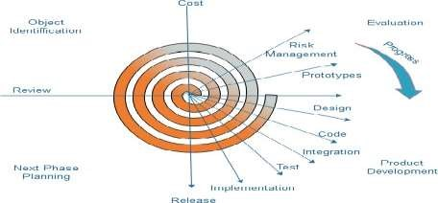

Figure 3.1: Spiral Model

The spiral model, initially proposed by Boehm, is an evolutionary software process model that couples the iterative feature of prototyping with the controlled and systematic aspects of the linear sequential model. It implements the potential for rapid development of new versions of the software. Using the spiral model, the software is developed in a series of incremental releases. During the early iterations, the additional release may be a paper model or prototype. During later iterations, more and more complete versions of the engineered system are produced.

**Each cycle in the spiral is divided into four parts:**

**Objective setting:** Each cycle in the spiral starts with the identification of purpose for that cycle, the various alternatives that are possible for achieving the targets, and the constraints that exists.

**Risk Assessment and reduction:** The next phase in the cycle is to calculate these various alternatives based on the goals and constraints. The focus of evaluation in this stage is located on the risk perception for the project.

**Development and validation:** The next phase is to develop strategies that resolve uncertainties and risks. This process may include activities such as benchmarking, simulation, and prototyping.

**Planning:** Finally, the next step is planned. The project is reviewed, and a choice made whether to continue with a further period of the spiral. If it is determined to keep, plans are drawn up for the next step of the project.

## 3.2 Hardware and software requirement

**3.2.1 Hardware Requirement**

* Computer
* Internet
* Mouse
* Keyboard
* Minimum 128 RAM
* Minimum 500 MB hard disk

**3.2.2 Software requirement**

The software is the non-physical part of the system that uses the hardware components to successfully run the system that has been built. The system must have word processor. The system will run windows Operating System.

Operating system: Windows, Linux Different software we used are:

Language: Python, OpenCV, Tkinter GUI Database: MYSQL

Spreadsheet: Excel

## 3.3 Software Description

**3.3.1 OpenCV**

OpenCV is a Python open-source library, which is used for computer vision in Artificial intelligence, Machine Learning, face recognition, etc. The purpose of computer vision is to understand the content of the images.

**3.3.2HAAR-Cascade Detection in OpenCV**

OpenCV provides the trainer as well as the detector. We can train the classifier for any object like cars, planes, and building by using the OpenCV.

There are two primary states of the cascade image classifier:

* first one is training and
* The other is detection.

OpenCV provides two applications to train cascade classifier **opencv_haartraining** and **opencv_traincascade.** These two applications store the classifier in the different file format. For training, we need a set of samples.

There are two types of samples.

* **Negative sample:** It is related to non-object images.
* **Positive sample:** It is a related image with detect objects.

A set of negative samples must be prepared manually, whereas the collection of positive samples is created using the **opencv_createsamples** utility.

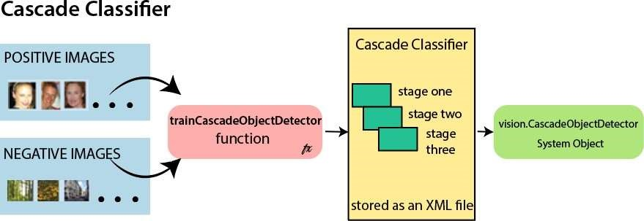

Figure 3.2:Cascade Classifier

**Steps of the Algorithm:**

1. First, we need to load the necessary XML classifiers and load input images in grayscale.
2. After converting the image into grayscale, we can do the image manipulation where the image can be resized, cropped, blurred, and sharpen if required. The next step is image segmentation; identify the multiple objects in the single image, so the classifier quickly detects the objects and faces in the picture.
3. The haar-Like feature algorithm is used to find the location of the human faces in frame or image.
4. In this step, we extract the features from the image, with the help of edge detection, line detection, and center detection. Then provide the coordinate of x, y, w, h, which makes a rectangle box in the picture to show the location of the file. It can make a rectangle box in the desired area where it detects the face.

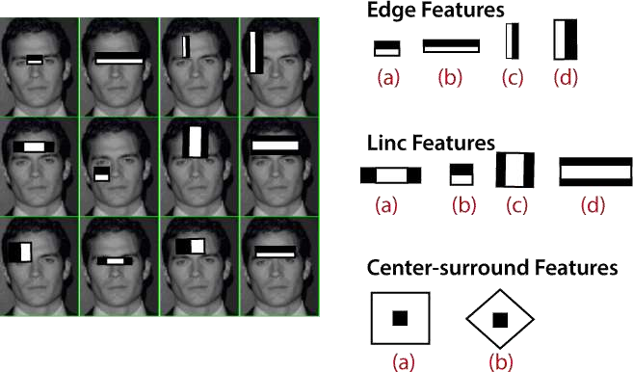

Figure 3.3: Face Feature Extraction

**3.3.3 LBPH algorithm**

Local Binary Pattern Histogram algorithm is a simple approach that labels the pixels of the image thresholding the neighborhood of each pixel.

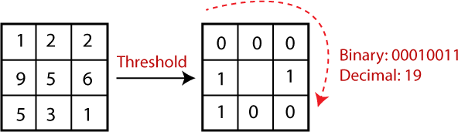

Figure 3.4: Binary Pattern

Steps of the algorithm:

1. Selecting the Parameters:

-The LBPH accepts the four parameters: Radius, Neighbors, Grid X, Grid Y

1. Training the Algorithm
2. Using the LBP operation
3. Extracting the Histograms from the image
4. Performing face recognition:

Use Euclidean distance based on the following formula:



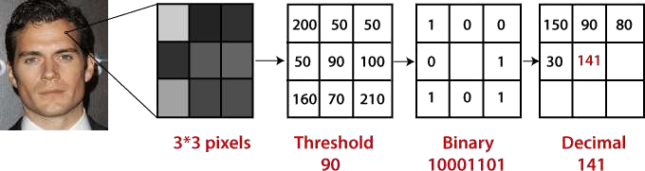

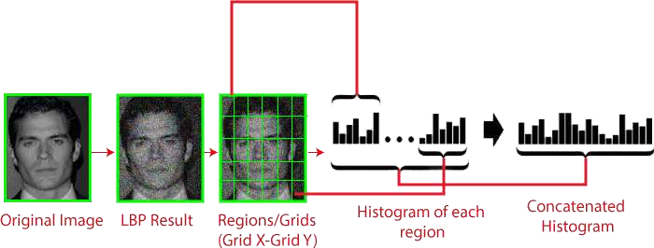

## 3.4 System analysis

Systems analysis is a process of collecting factual data, understanding the processes involved, identifying problems and recommending feasible suggestions for improving the functionality of the system. This involves studying the business processes, entity relationships gathering operational data, understand the information flow, finding out bottlenecks and evolving solutions for overcoming the weaknesses of the system to achieve the organizational goals. System Analysis also includes decoupling of complex processes that make up the entire system, identification of data store and manual processes.

## 3.5System design

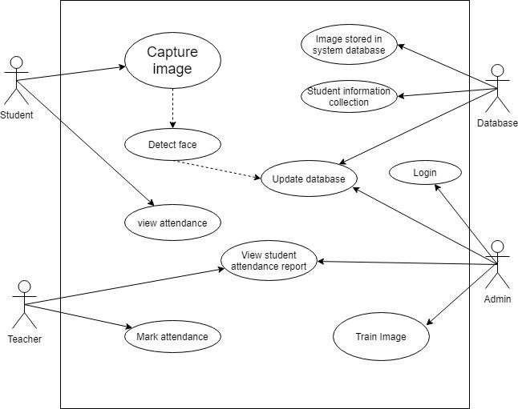

Figure 3.5: Use-case diagram for Face recognition attendance system

## 3.6 Block diagram

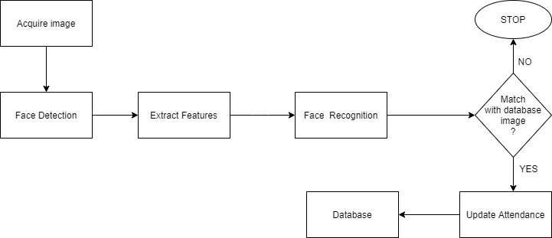

Figure 3.6: Block Diagram for Face recognition and detection-based attendance of student

## 3.7Class Diagram

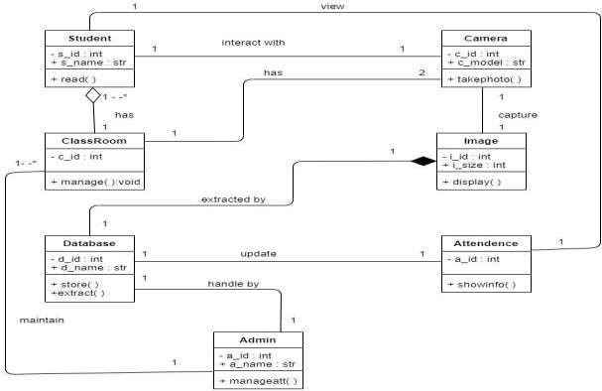

Figure 3.7: Class Diagram for Face recognition attendance System

## 3.8 Entity Relationship diagram

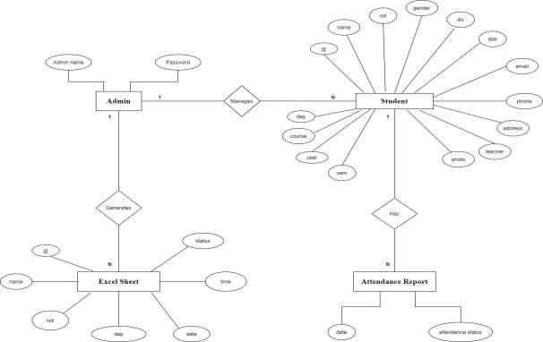

Figure 3.8: ER Diagram for Face recognition attendance system

## 3.9 Sequence diagram

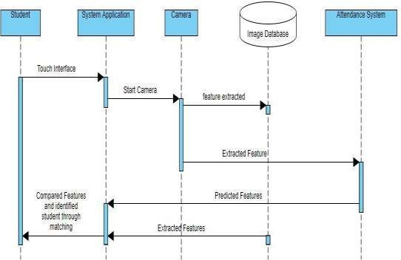

Figure 3.9: Sequence Diagram for Face recognition attendance System

## 3.10 Working principle

**Algorithm: For Admin**

Step 1: START

Step 2: Go to Home

Step 3: Do you have an account?

3.1: If yes, Login to account

1. 1.1: Go to the Home Page
   1. 1.1: Manage Student Detail, Image Process and Manipulate

3.1.1.2: Export the attendance detail

3.1.1.2.1: No, exit

3.2: If no, register for the account and go to step 3 Step 4: STOP

**Algorithm: For Face recognition and detection-based attendance of student**

Step 1: START

Step 2: Image stored in System data base

Step 3: Recognition Process start

Step 4: Camera Capture the User image Step 5: Compare With database image

5.1: If Match

1. 1.1: Present to the student
   1. 1.1: A file generated with student detail

5.1.1.2: Export the attendance detail

5.1.1.2.1: exit, go to step4

5.2: If no match, go to step 4

Step 6: STOP

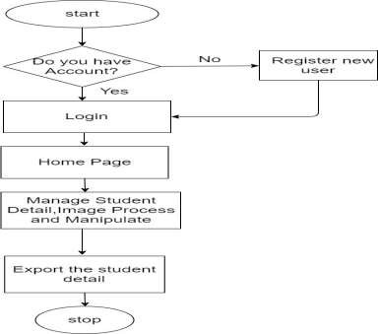

Figure 3.10: Flow chart for Admin

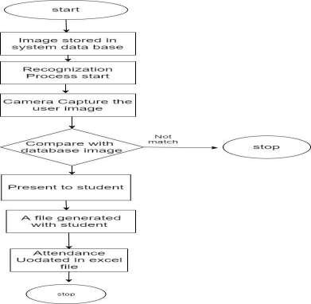

Figure 3.11: Flow chart for Face recognition-based attendance system

**Chapter 4**

# WORKS COMPLETED

## 4.1Works Completed

1. User can register the new admin, and User can also reset the password.
2. User can view the home page of the project
3. User have taken the dataset and trained the dataset.
4. User have designed different types of diagrams like Use case Diagram, Class Diagram and Sequence diagram etc. for documentation
5. User can do the database part of the project.
6. Facial detection and recognition work have been completed.
7. Once face of the student is detected, it recognizes the student and marks attendance. 8.Tabular representation of attendance data is done generating a csv file.

9.Data can be retrieved easily. 10.Validation of the data.

11.Included voice-command.

## 4.2Problems Encountered

* The main problems of face recognition is large variability of recorded image due to pose, illumination condition, facial expression, different hairstyles, presence of glasses, beard.
* Difficulties in code writing.
* Difficulty to overcome ambiguity.
* It is often very difficult to maintain and update all the records and retrieve certain data.

**Chapter 5**

# RESULT ANALYSIS AND CONCLUSION

## 5.1 Result and Analysis

Over a span of 10 weeks, our team “kyzen” was successful in completing a proof of concept demonstrating an Attendance System based on Facial Recognition. The following screenshots in Appendices section of the application home page demonstrates the key functionality the application provides.

**Output Screenshots:**



Figure 5.1: Admin/User Login Home Page

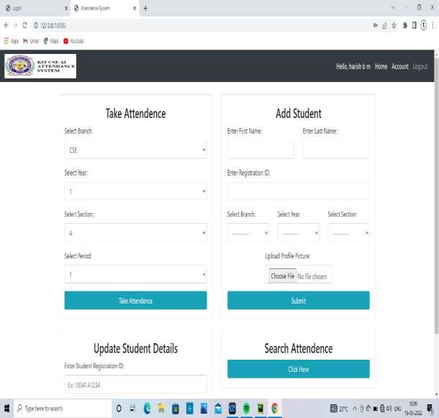

Figure 5.2: Student Management System Interface



Figure 5.3: Student Registration Page

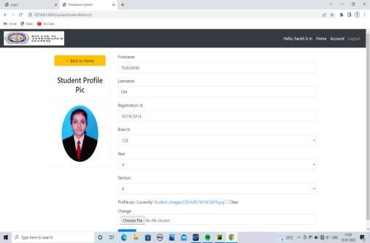

Figure 5.4: Student Profile Page

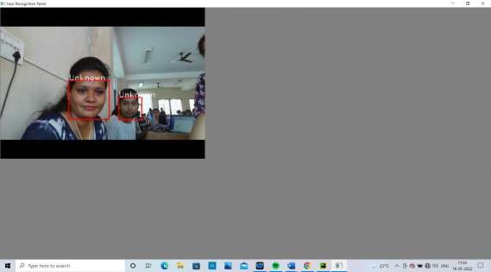

Figure 5.5: Unknown Face with less accuracy



Figure 5.6: Student Attendance Details



Figure 5.7: Deleting Student Attendance Details

**Chapter 6**

# CONCLUSION

Nowadays, various attendance and monitoring tools are used in practice in different places regardless of the fact that these solutions are mostly automatic, they are still prone to errors.

In this Face Recognition based student attendance system, we have used OpenCV, a Python open-source library, which is used for computer vision in Artificial intelligence, Machine Learning, face recognition, etc. that provides HAAR-Cascade Detection and LBPH algorithm for face recognition. By using the technology to conquer defects cannot merely save resources but also reduces human intervention in the whole process by handling the entire complicated task to storage. It is determined that with the required number of face images along with the proposed method of augmentation high accuracy can be determined.

To wrap up, the system not only resolves troubles that exist in the traditional model of attendance but also provides convenience to the user to access the information collected by creating the CSV file.

**Chapter 7**

# LIMITATIONS AND FUTURE SCOPE

The team “kyzen”, identified some limitations which opens the door to opportunity for improvement and further enhancement in this project.

## 7.1 Limitations

1. The major limitation of the face recognition model is the recognition of a person’s 2D image. This leads to the attendance of being marked if the picture of a student is shown. Some face recognizers are made to detect the depth of faces and hence cannot be incorporated in this project.
2. Another constraint is that in this project 100 images of each student are taken for better accuracy. 100 images per student in a larger university/college would consume a massive volume to store the images.
3. Sometimes there may occur illumination and pose problems. And also the system can’t detect face with masks.
4. Small image sizes make facial recognition more difficult.
5. The current face recognition model is 96.78%.

## 7.2 Future Scope and Recommendation

1. A feature which can give intruder alert can be included in the system. Further more, the images of unknown people can be saved in an efficient manner and displayed in the system for better security.
2. Automatic mail alert/response to the parents regarding the presence and absence of the students can be added.
3. The number of training images can be reduced by removing duplicate images of the same person, or images with similar embedding.
4. The training time can be reduced by retraining the classifier only for the newly added images.
5. Wrongly classified images can be added to the training dataset with the correct label so as to increase the accuracy of the recognition model.

**Chapter 8**

# REFERENCES

1. “Smart Attendance Management and Analysis with Signature Verification”(Hardika Chauhan, Chitaliya Nehal,2017)
2. “Fingerprint Based Attendance System Using Microcontroller and LabView” (Kumar Yadav, Singh, Pujari, Mishra, 2015)
3. “A Proposed RFID Based Student Attendance System “(Fawzi M Al-Naima and Maryam Alaa Saleh, (1 May) 2015)
4. Charles A. Walton, electronic identification & recognition system Filed: Dec. 27, 1971 Appl. No.: 212,281.
5. Lee, S. and Li, S. (2007). Advances in Biometrics. Berlin: Springer.
6. Kasar, M., Bhattacharyya, D. and Kim, T. (2016). Face Recognition Using Neural

Network: A Review. International Journal of Security and Its Applications, 10(3), pp.81-100.

1. Kihwan Kim. (2011). Computer Vision Final Project:Viola-Jones & Morphology- based Face Detector. [online] Available at:

https:/[/www.cc.gatech.edu/~kihwan23/imageCV/Final2005/FinalProject_KH.htm](http://www.cc.gatech.edu/~kihwan23/imageCV/Final2005/FinalProject_KH.htm)[Accessed 22 Apr. 2018].

1. Mikael Nilsson, Jorgen Nordberg,and Ingvar Claesson “Face detection using local SMQT features and split up SNOW classifier in IEEE International conference on Acoustics, Speech, and signal processing(ICASSP),2007,vol 2, pp. 589-592.
2. Smart Attendance System using Computer Vision and Machine Learning ( Dipti

Kumbhar#1 , Prof. Dr. Y. S. Angal*2 # Department of Electronics and

Telecommunication, BSIOTR, Wagholi, Pune, (7 July) 2017)